Objective and Data
The objective of the project was to construct and evaluate equity portfolios using mean–variance optimization and to compare three optimized portfolios against a SPY benchmark. I focused on nine U.S. stocks: defensive/real-economy names (JNJ, KO, EOG, NEM, ADM) and technology/growth names (MSFT, ADBE, AMAT, NVDA), covering a spectrum from low-beta defensives to high-beta growth.​
I downloaded daily adjusted close prices from Yahoo Finance via yahoo finance for the period 2015-01-01 to 2025-01-01, cleaned missing values, and converted prices into daily log and simple returns, saving the log-return series for subsequent analysis.​
Ticker | Sector / Theme | Why it was chosen | Beta vs SPY | Exp. annual return (%)
JNJ | Healthcare | Defensive healthcare exposure with stable earnings that can help dampen portfolio drawdowns. | 1.293 ​ | 6.02​
KO | Consumer Staples | Classic staples name with resilient cash flows and lower cyclicality than the overall market. | 0.829​ | 7.10​
EOG | Energy (Oil & Gas) | Upstream energy exposure to add commodity and inflation sensitivity. | 1.611​ | 5.64​
NEM | Gold Mining | Proxy for gold/safe-haven behavior that can diversify equity risk in stress periods. | 1.091​ | 8.87​
ADM | Agriculture / Commodities | Agriculture and grain processing exposure, tying returns to food and crop prices. | 0.544​ | 6.20​
MSFT | Large-Cap Tech / Cloud & AI | Broad technology platform and AI leader, core growth engine with diversified revenue streams. | 0.595​ | 7.35​
ADBE | Software / Digital Media | High-margin subscription software in creative and marketing tools, diversifying tech beyond infrastructure. | 1.226​ | 26.56​
AMAT | Semiconductors Equipment | “Picks and shovels” supplier to the chip industry, giving cyclical but equipment-focused exposure. | 0.393​ | 9.28​
NVDA | Semiconductors / AI Chips | Dominant AI GPU provider, intentionally used as the very high-growth, high-beta component. | 1.754​ | 75.74​
SPY | S&P 500 Benchmark | - | 1.000 | 13.81

Estimating Returns, Risk, and the Efficient Frontier
Using the daily log returns, I computed annualized expected returns and the 9×9 annualized covariance matrix. I then wrote a custom portfolio stats function to calculate portfolio-level expected return, volatility, and Sharpe ratio (with a 5% risk-free rate) for arbitrary weight vectors.​
To visualize the opportunity set, I generated 10,000 random portfolios, recorded their statistics, and plotted a scatter of annualized return vs. volatility, color-coded by Sharpe ratio. This Monte-Carlo “cloud” approximates the efficient frontier and illustrates how diversification across my chosen asset’s trades off risk and return.​
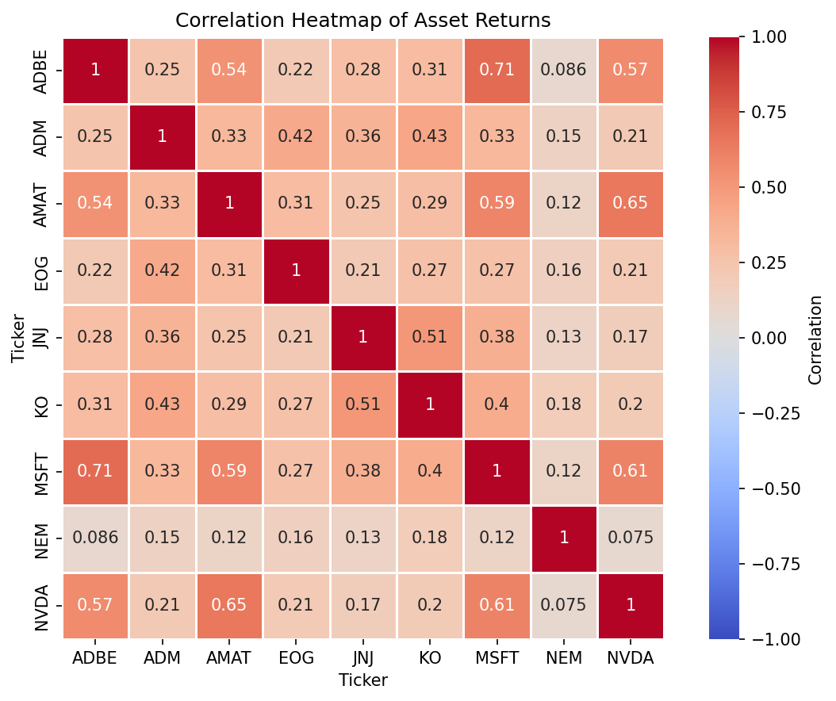

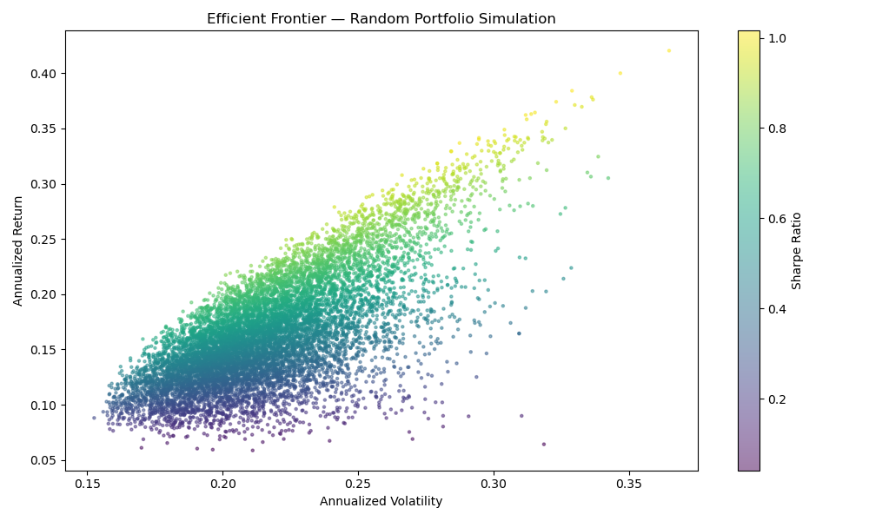

Optimizing Portfolios
Next, I re-loaded the cleaned price data and used PyPortfolioOpt to compute more robust inputs: historical mean returns and a Ledoit–Wolf shrinkage covariance matrix. With these inputs, I employed the Efficient Frontier class to solve three optimization problems:​
- Maximum Sharpe portfolio, which maximizes the Sharpe ratio at a 5% risk-free rate.
- Minimum volatility portfolio, which minimizes total portfolio variance.
- 20% target-return portfolio, which minimizes risk subject to achieving a 20% annual expected return.​
For each portfolio, I extracted cleaned weights, annualized expected return, volatility, and Sharpe ratio, and summarized them in tables and plots of asset allocation by strategy. These outputs show that the Max Sharpe solution is highly concentrated in NVDA, the Min Vol portfolio tilts heavily toward low-beta defensive names, and the 20% target portfolio lies between them with a diversified but growth-oriented mix.​
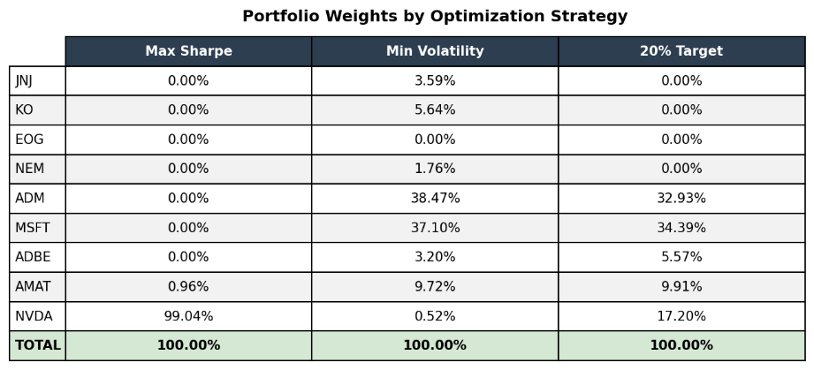

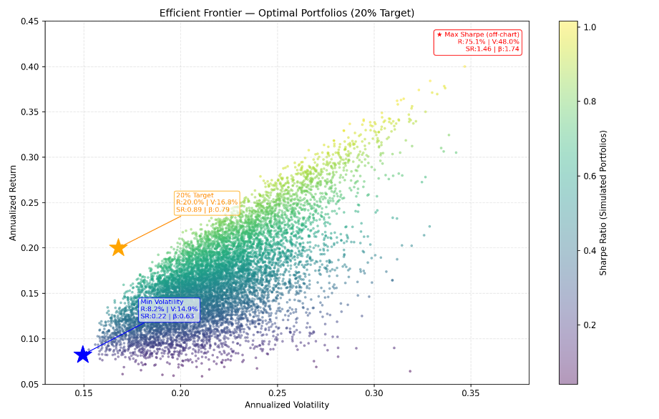

Back testing and Performance Evaluation
To evaluate realized performance, I downloaded SPY as a benchmark and constructed daily return series for each optimized portfolio by applying the static weights to the underlying stock returns. I then computed standard back test metrics over 2015–2025:​
- Annualized return and volatility.
- Sharpe ratio versus a 5% risk-free rate.
- Maximum drawdown from cumulative returns.
- Total cumulative return over the sample.​
I also estimated betas by regressing daily stock and portfolio returns on SPY returns, obtaining individual stock betas and overall betas for the Max Sharpe, Min Vol, and 20% Target portfolios. These betas quantify each portfolio’s sensitivity to the market and help interpret their risk profiles.​
The performance summary table, exported to backtest_summary.csv, consolidates these metrics so that each strategy can be compared directly to SPY on return, volatility, Sharpe ratio, drawdown, total return, and beta.​
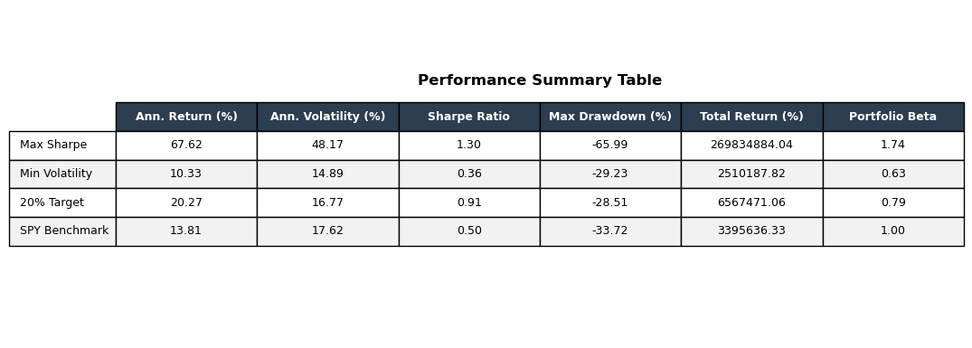
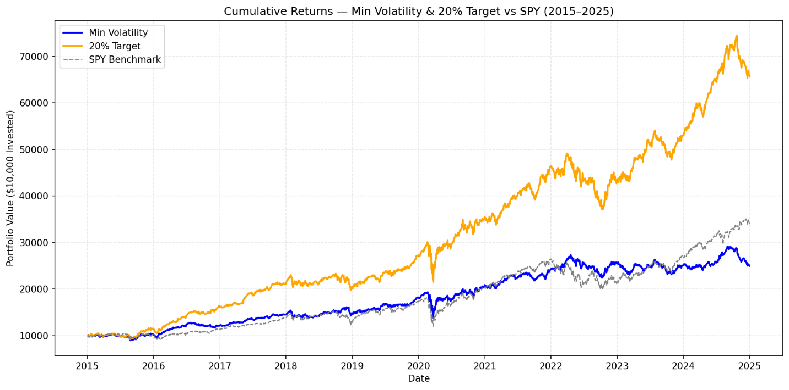
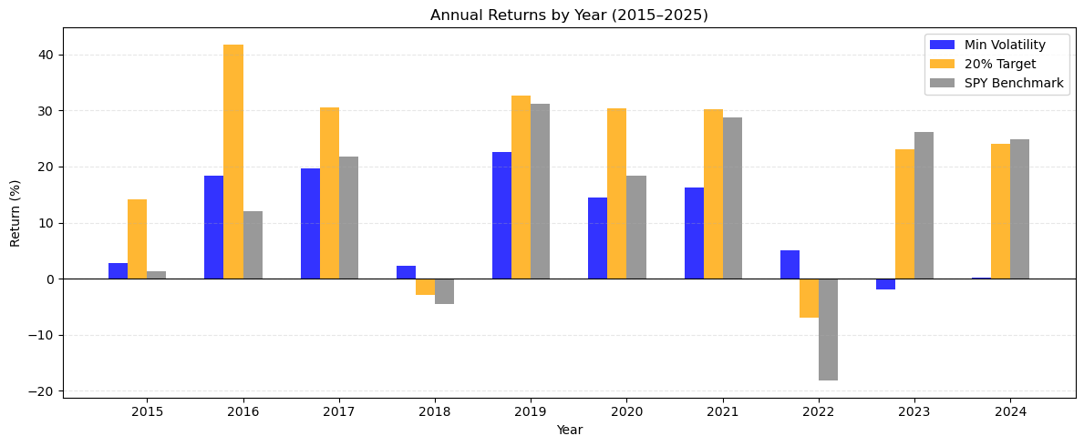
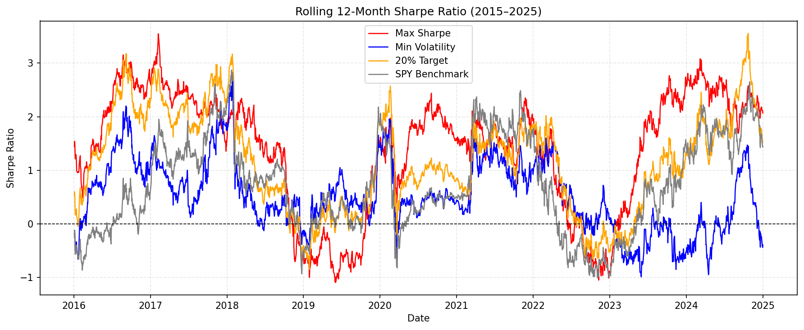
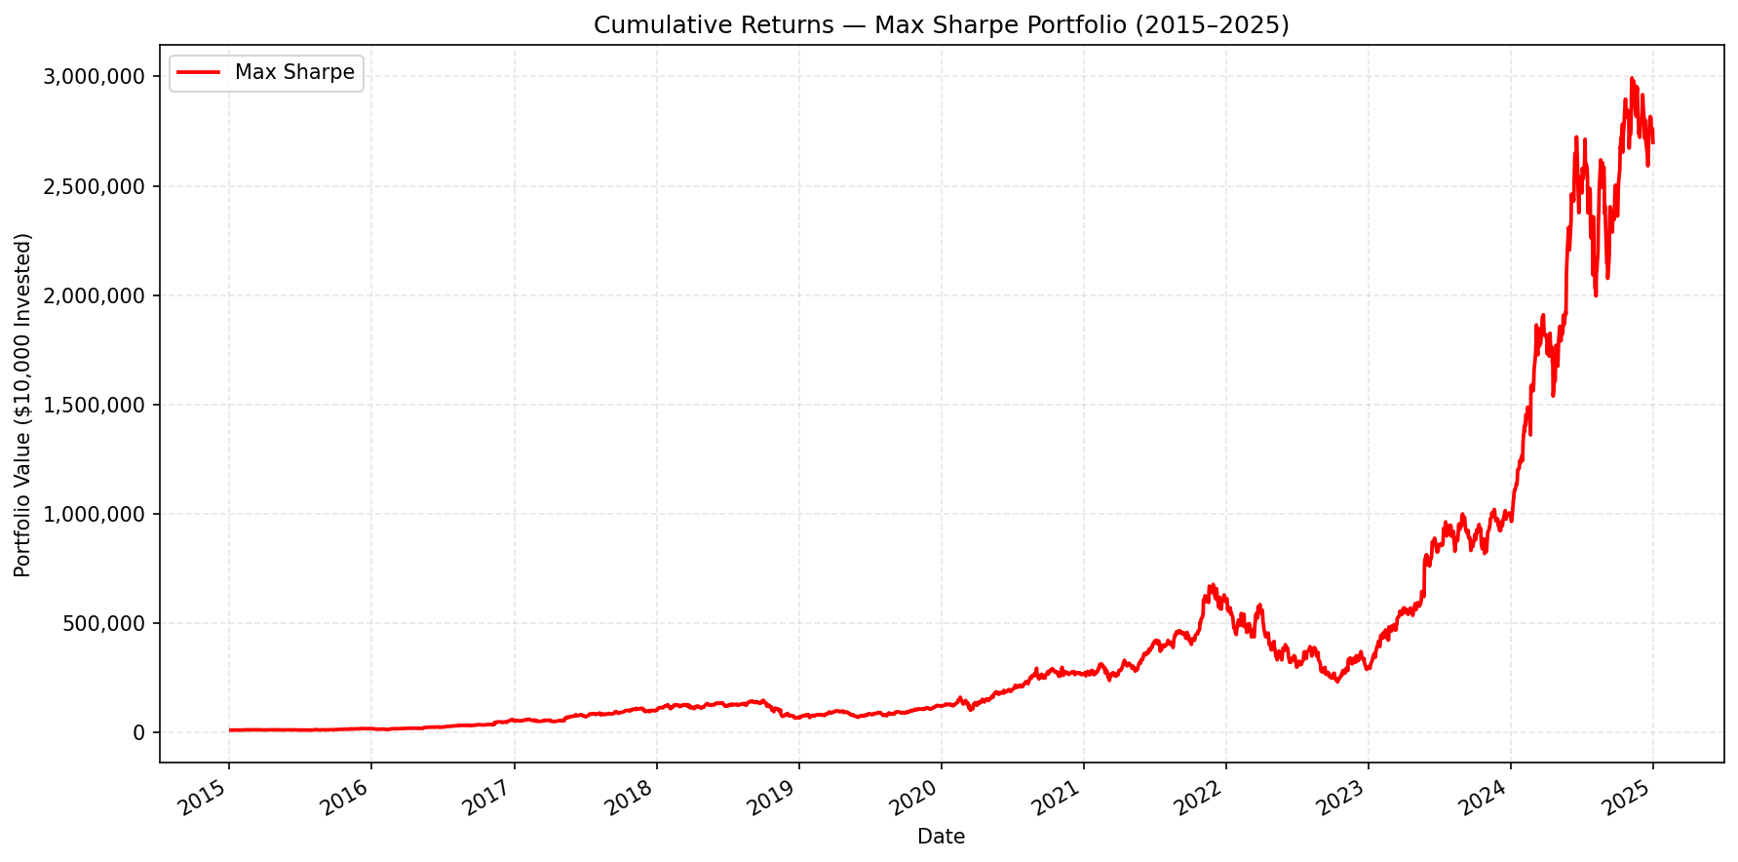
Interpretation and Conclusion
The results show clear trade-offs. The Max Sharpe portfolio achieved the highest expected and realized return but did so by concentrating almost entirely in NVDA, resulting in very high volatility, beta, and large drawdowns. The Min Volatility portfolio delivered the smoothest ride with the lowest volatility and drawdowns, but at the cost of materially lower return.​
The 20% target-return portfolio emerged as a balanced compromise. It sits on the efficient frontier, offers a significantly higher return profile than the Min Vol portfolio and SPY, and maintains a beta below 1.0 and smaller drawdowns than the extremely concentrated Max Sharpe solution. Based on these quantitative results, I conclude that the 20% target-return portfolio is the most reasonable choice for a risk-aware investor in this universe and that the project successfully demonstrates how Markowitz optimization and back testing can be used together to design and evaluate realistic portfolios.​

